Kendra Maggiore

5/2/19

Machine Learning Homework 2: CNN

For homework 2, in machine learning we had to create a CNN to process Fashion-MNIST consists of 60,000 training images and 10,000 test images, using 12 different labels. For this task I used keras, and tenorflow backend. I also used matplotlib to plot my graphs. I set up my CNN using the keras example for class, but I changed the model to improve the accuracy and variance.

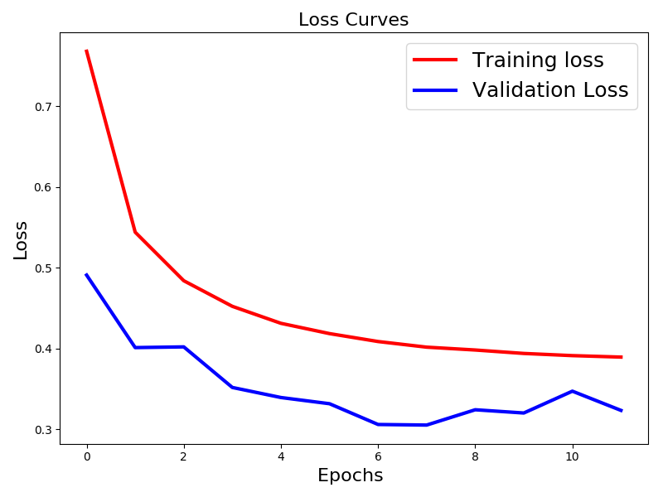Using just the keras example from class without changing it. I was only able to achieve a 18% accuracy. I used relu and softmax, and then I used an image data generator to feed the CNN more bad data. I changed the width, and height of the data by 0.1. I also had the image data generator horizontally flip the data. I then fit the model with the image data generator. I ran 469 tests with 12 epochs. It took about 3 minutes per epoch to run. I was able to achieve an almost 87% on testing data, and 89% on validation data.

The graph above shows my loss curves between the training data, and the validation data. The training data has a nice downward curve in relation to the epochs going up. While the validation data, has some fluctuation in the curve. I would say this is due to the train set having 60,000 images to train on while the validation set only had 10,000.

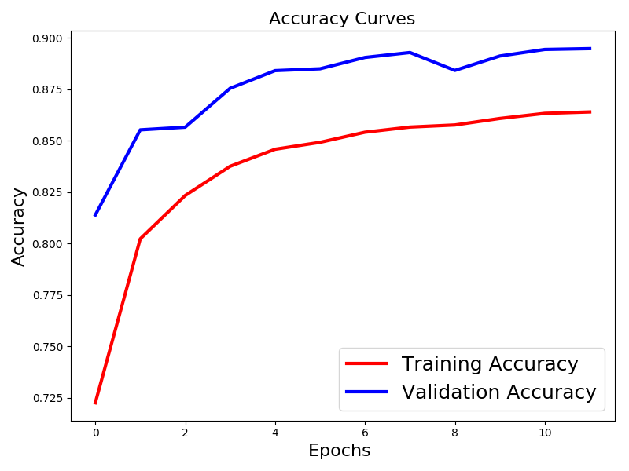The graph below shows the accuracy curves between the training data, and the validation data. Again, we can see a smooth curve for the training set, and a fluctuating curve for the validation set. I would also attribute this to the train set having 60,000 images to train on while the validation set only had 10,000.

In conclusion, I believe that achieving around 89% on this dataset was pretty good. I think that maybe having less labels, and more epochs could help the accuracy moving forward.